[](https://ok.ru/dk?cmd=PopLayerPhoto&st.layer.cmd=PopLayerPhotoOuter&st.layer.type=GROUP&st.layer.revNav=off&st.layer.limitedUi=false&st.layer.sphotoIds=859178200704;859178200448;859178200192&st.layer.showNav=on&st.layer.photoAlbumId=51307198677120&st.layer.epm=off&st.layer.photoId=859178200704&st.layer.opl=off&st.layer.navStartPhotoId=859178200704&st.layer.sbd=off&st.cmd=userPage&st._aid=GroupTopicLayer_openPhotoLayer)

[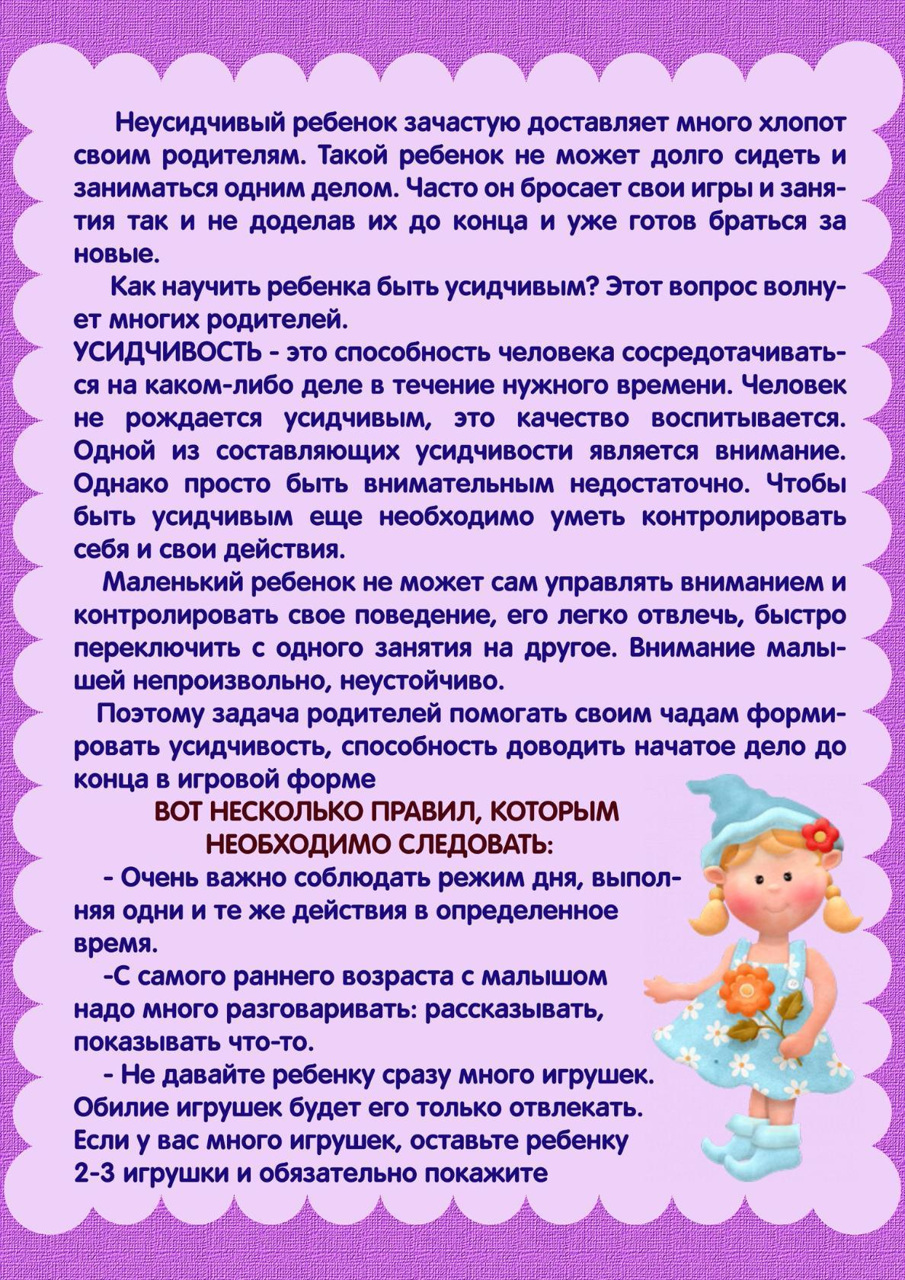](https://ok.ru/dk?cmd=PopLayerPhoto&st.layer.cmd=PopLayerPhotoOuter&st.layer.type=GROUP&st.layer.revNav=off&st.layer.limitedUi=false&st.layer.sphotoIds=859178200704;859178200448;859178200192&st.layer.showNav=on&st.layer.photoAlbumId=51307198677120&st.layer.epm=off&st.layer.photoId=859178200448&st.layer.opl=off&st.layer.navStartPhotoId=859178200448&st.layer.sbd=off&st.cmd=userPage&st._aid=GroupTopicLayer_openPhotoLayer)

[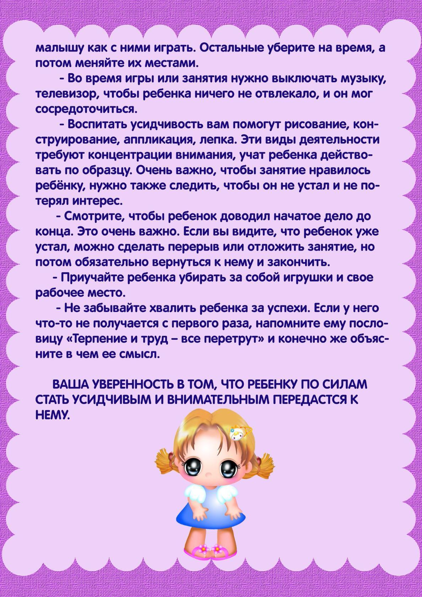](https://ok.ru/dk?cmd=PopLayerPhoto&st.layer.cmd=PopLayerPhotoOuter&st.layer.type=GROUP&st.layer.revNav=off&st.layer.limitedUi=false&st.layer.sphotoIds=859178200704;859178200448;859178200192&st.layer.showNav=on&st.layer.photoAlbumId=51307198677120&st.layer.epm=off&st.layer.photoId=859178200192&st.layer.opl=off&st.layer.navStartPhotoId=859178200192&st.layer.sbd=off&st.cmd=userPage&st._aid=GroupTopicLayer_openPhotoLayer)